CALDERDALE WAY RELAY RECCE
SATURDAY 4th MAY 2024
Members of Halifax Harriers will guide runners round all the legs of the CWR.
These recce’s are for both Halifax Harriers members and members of ALL OTHER CLUBS,
Each leg will be run at a pace that all runners can manage.
We will operate a car sharing system. Please meet at the end of your chosen leg at 8:20am, we will leave half of the cars here and drive at 8:30am in the remaining cars to the start of the leg. The runs will aim to start at 9:00/9:15am. On completion of the run we drive back to the start to collect the other cars.
PLEASE ADDRESS ANY QUESTIONS TO THE LEADER OF EACH LEG
LEG 1 WEST VALE TO CRAGG VALE (meet at Cragg Vale)
Run leader Lee Cattermole Mobile 07812 586474

Park on main road B6138 in Cragg Vale above Hinchliffe Arms.
PLEASE DO NOT USE WALLS AND TREES NEAR HOUSES FOR A TOILET
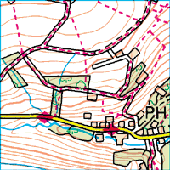
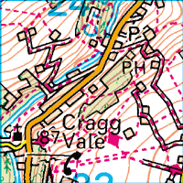
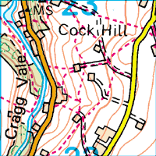
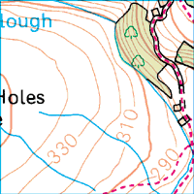
PARK HERE
RUNS FINISHES HERE

LEG 2 CRAGG VALE TO TODMORDEN (meet at Todmorden Swimming Baths top car park, OL14 7DF)
Marc Rocheteau Mobile 07941652318
PLEASE DO NOT USE WALLS AND TREES NEAR HOUSES FOR A TOILET
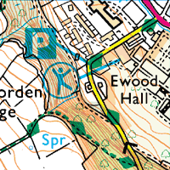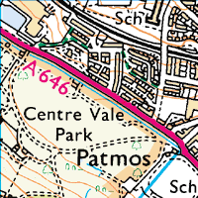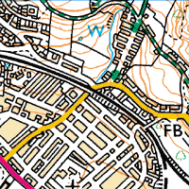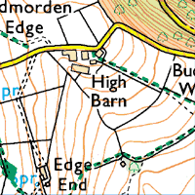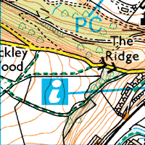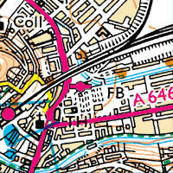
PARK HERE
RUNS FINISHES HERE

LEG 3 TODMORDEN TO BLACKSHAW HEAD (meet at junction in middle of Blackshaw Head, HX7 7JY)
Park on OLD SHAW LANE away from village centre.
Run leader Nick Small Mobile 07761 072146
PLEASE DO NOT USE WALLS AND TREES NEAR HOUSES FOR A TOILET

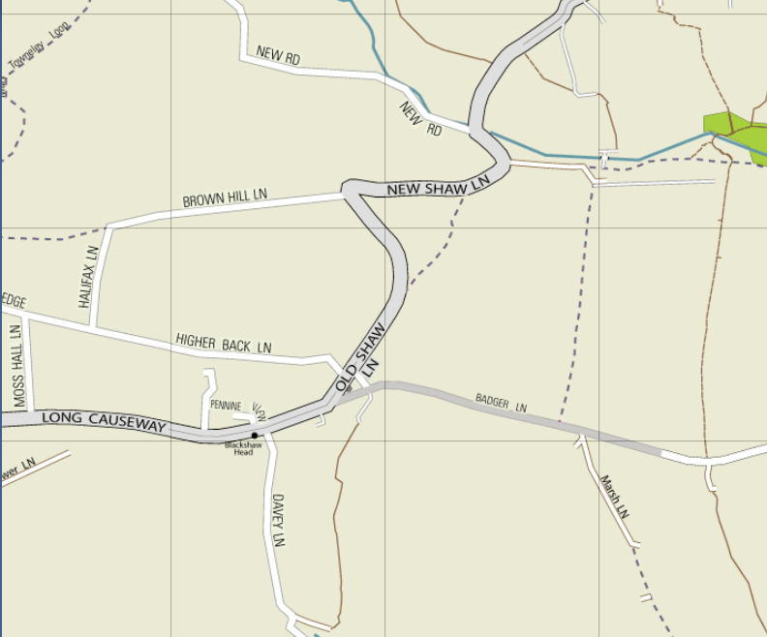
BLACKSHAW HEAD
RACE FINISHES HERE

PARK HERE

LEG 4 BLACKSHAW HEAD TO WAINSTALLS (meet at change over point at Wainstalls)
Run leader Will Carver Mobile 07814 817477
PLEASE DO NOT USE WALLS AND TREES NEAR HOUSES FOR A TOILET
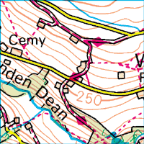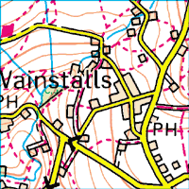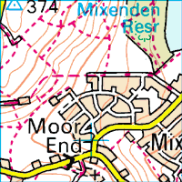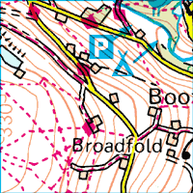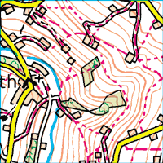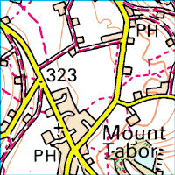
PARK HERE
RUNS FINISHES HERE

LEG 5 WAINSTALLS TO SHELF (meet at car park at side of Shelf Park, close to change over point) HX3 7NW
Run leader Angela Clarke Mobile 07528 724073
PLEASE DO NOT USE WALLS AND TREES NEAR HOUSES FOR A TOILET

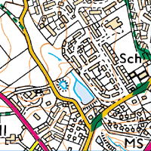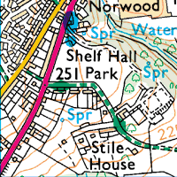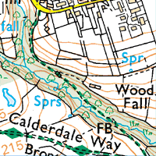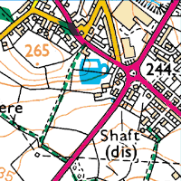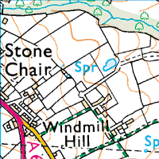
PARK HERE
RUNS FINISHES HERE

LEG 6 SHELF TO SPRING HALL ATHLETICS TRACK (meet at Spring Hall Athletics Track, HX1 0AA)
Run leader Ryan Barker Mobile 07410 540654
PLEASE DO NOT USE WALLS AND TREES NEAR HOUSES FOR A TOILET
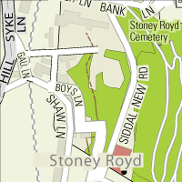
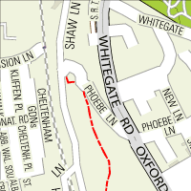
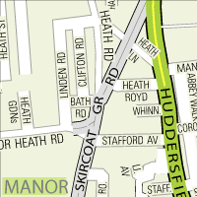
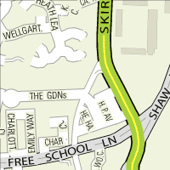
The CWR finishes on the side of the running track.
Park in lower car park at Spring Hall. Postcode HX3 0AQ

