HALIFAX HARRIERS SUMMER 10K HANDICAP
Tuesday 11th July 2023.
Registration and number collection 6:30 in bottom car park by the Mansion at Spring Hall, race starts at 6:45pm.
The race is for all senior members. The slower runners will start first and the fastest runner last.
If the handicapping is worked out correctly all runners should finish at the same time with the first runner back receiving the trophy.
The race is free to enter, just let Nigel Rigg know you are running and tell him what time you think you can run a 10k in at present. (NO CHEATING WITH YOUR TIME PLEASE)
The race starts at the top of the Hebble Trail and goes down to the end of the Hebble Trail before continuing on the canal to Sowerby Bridge and returns the same way.
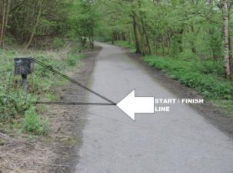
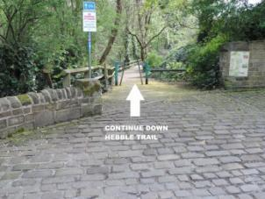

At the end of the Hebble Trail bear right under tunnel.
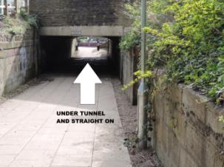
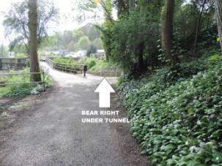
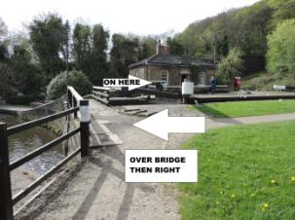
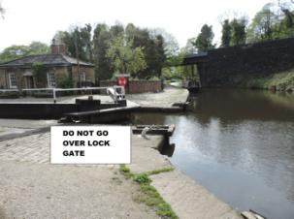
Do not go over Lock Gate, turn left and over Stone Bridge, then right towards Sowerby Bridge.

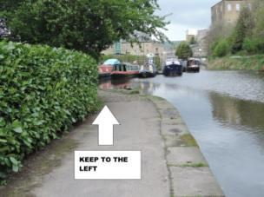
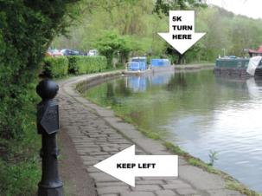
When entering Sowerby Bridge canal basin keep to the left.

Turn round at the post and return the way you came.
KEEP LEFT OVER THE COBBLES AND ROUND THE CORNER

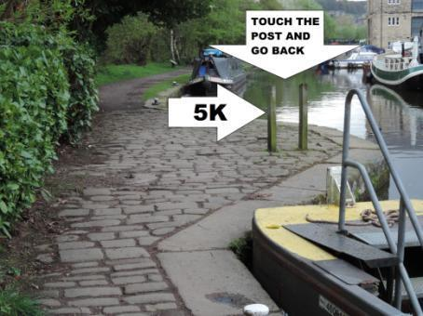

After the race we have the trophy presentation and refreshments
from 8:00pm to 9:00pm.

Remember to let Nigel Rigg know your
estimated 10k time.
nrigg@hotmail.com

