Halifax Harriers Calderdale Way Relay
Licensed By The FRA.
Race Instructions – 17th May 2026

NEW FOR 2026 – MUST READ
- Teams that do not cross the finish line TOGETHER will incur a two minute time penalty and this will be strictly enforced.
- Anyone disrespecting or abusing an official or marshal (especially holding marshals) will result in their whole team being disqualified – I should not have to be saying this in 2026!
- The advice for obtaining medical assistance has been updated. Please read the separate addendum at the end of this document.
- There is another slight change to the leg 5/6 changeover, please read the revised instructions lower down carefully.

It’s the return of hot food at the finish! – Bring your number to receive loaded fries with a choice of toppings including vegetarian.

IMPORTANT INFORMATION FOR THE EVENT
This information must be read and digitally signed by every member of your team.
It is the Team Managers responsibility to ensure compliance.
KEY CONTACTS
Race Organiser: Nigel Rigg (07710 876095 – entries.calderdalewayrelay@hotmail.co.uk)
Emergency Contact Number on day of race: (07934 775189)
Race Website: http://www.halifaxharriers.co.uk/club/club-races/calderdale-way-relay/
Race HQ: Halifax Harriers, Spring Hall Athletics Track, Huddersfield Rd, Halifax HX3 0AQ

IMPORTANT – All runners are responsible for checking the weather forecast and preparing accordingly for adequate hydration, medication, sunscreen, changes of clothes, food etc at the changeover points. Look out for each other as a team: i.e. Have water in plentiful supply.

All runners MUST run in pairs, NEVER more than 20 metres apart and MUST cross the finish line timing mats together.

All runners MUST familiarise themselves with the FRA Safety Requirements & Rules for Competition which can be found on the FRA Website at

http://www.fellrunner.org.uk/documents/2026/FRA-Requirements-for-Runners-2026.pdf

IMPORTANT - KIT REQUIREMENTS

This is a fell race and, although not mandatory, all runners are expected to carry sufficient food AND WATER for their own needs whilst out on the course and for post-race requirements.

LEGS 3, 5 AND 6
Kit for these legs will be weather dependant and at the discretion of the race director – come prepared. Regardless of that decision, runners are expected to carry suitable body cover appropriate for the weather conditions and your individual ability on the day. A mobile phone with the number registered with the race organiser, as per the team list, is recommended to be carried.

LEGS 1, 2 AND 4
REQUIRED EQUIPMENT (to be carried by all runners)
All runners MUST carry all of the following equipment throughout the race:
- WATERPROOF whole body cover (i.e. covering the torso from head to ankles)
- Hat (for warmth and/or sun protection). As per FRA guidance a buff is acceptable.
- Gloves
- Map of the race route and surrounding area (with grid lines for compass use)
- Compass suitable for navigating the course
- Whistle
- HIGHLY RECOMMENDED – mobile phone of the registered number with the race organiser (as per team list)

ALL runners must present their kit at race registration for inspection. No kit, No run.
ALL leg-leading runners and at least 10% of other competitors will have a mandatory kit inspection on finishing.
Failure to run with the required kit will result in the disqualification of the whole team.

RETIREMENT PROCEDURE
Any runner who retires from the race must report to a race marshal at either the start or finish of their leg or contact race control on the emergency number, which is printed on your race number. Failure to do so will mean disqualification of the whole team.

REGISTRATION AT LEG ONE – THE START
Arrange for your first leg runners to register between 07:00 and 07.30 at West Vale Primary School, Stainland Road, Halifax HX4 8LS. The race starts at 8am prompt from the grounds of Clay House opposite the school.

Team managers must ensure each member of the team have completed the online registration by 5pm on 15th May 26. Any changes after this date must be in writing to entries.calderdalewayrelay@hotmail.co.uk
Failure to follow the above instruction may result in none registered runners being unable to start and the team recording a DNF.

LEG REGISTRATION TIMES
Hinchliffe Arms 08:00 – 0900 Blackshaw Head 10:00 – 11:30 Shelf 12:00 – 13:30
Todmorden Leisure Centre 09:00 – 10:30 Wainstalls Road 11:00 – 12:30

LEG CUT OFF TIMES
Hinchliffe Arms 09.45 Blackshaw Head 12.00 Shelf 14:00
Todmorden High School 11.00 Wainstalls 13:00

ROAD CROSSING POINTS
Runners are reminded to take great care at road crossings, this means do NOT take risks … traffic has right of way …particularly at
Ripponden on Leg 1,
Rochdale Road Todmorden on Leg 2,
Great care must be taken when crossing the railway line near Todmorden on Leg 2.
Burnley Road Todmorden on Leg 3,
Bradford Road at Shelf on Leg 5 - NEW
Leeds Road after Norwood Green on Leg 6, and
Brighouse Road (twice) on Leg 6.

On the few sections of the route where running in the road is required, TAKE GREAT CARE, RUN IN SINGLE FILE and GIVE PRIORITY TO VEHICLES.

RACE RULES

The race is open to runners 18 years of age or older (16 years or over with parental consent on leg 3). Age as at 31st Dec 2026. Any runner under the age of 18 on the day of the race must submit a consent form with their team sheet at the start of leg 1.

Mixed teams must have a minimum of 6 female runners in order to qualify for the mixed category. Vets teams must comprise of men aged 40+ or women aged 40+ on the day of the race.

Each leg must be run in pairs, individual runners will not be allowed to run. Runners must finish in pairs and individual runners will be held approx. 100 meters from the leg finish until their partner arrives.

Each team will be provided with a baton at the start of leg 1. Teams arriving at the changeover point before the cut-off time will pass the baton to the next pair with the aim of ‘getting the baton round’.

All runners must present their kit for inspection at the start of all legs, unless the race director deems this not necessary for legs 3, 5 and 6..

If requested to do so, runners must make their kit available for inspection at the end of their leg. Failure to do so will result in disqualification of your entire team from the race.

Runners must register in pairs at the start of each leg. Individual runners will not be allowed to register.

Each runner must wear the supplied race number on the front of their vest/top in a way that is clearly visible to race marshals. Race numbers must not be folded or cut down. Race numbers will be issued at the start of each leg.

Club colours must be worn by UKA registered teams. Other teams must wear matching kit.

SECOND CLAIM ATHLETES – As per FRA rules, an athlete may usually only compete for their primary (“first claim” or “first claim other”) club. However, the race organiser, in accordance with the FRA guidance on exceptions, will agree to second claim runners taking part IF (A) the primary club’s secretary agrees in writing AND (B) the primary club DOES NOT also have a team competing in the event.

Team managers are responsible for checking that none of their runners are prohibited from running by the FRA or UKA either because of bans or club transfer issues.

Where a team has insufficient runners to complete the race, it is permitted for a runner to “double up” and run two legs of the race. Runners may only run a maximum of two legs and are still required to register and undergo a kit check at the start of each leg. PLEASE NOTE, WHERE A CLUB HAS MORE THAN ONE TEAM, AND THE LEAD TEAM (i.e. A Team) IS SHORT OF A RUNNER, THAT REPLACEMENT RUNNER SHOULD COME FROM ONE OF THEIR OTHER TEAMS (i.e B, Mixed or vets team), WITH THE LEAD TEAM RUNNER SUBSTITUTING FOR THEM (in the B, Mixed or Vets team).

If a team discovers that an earlier leg pair have not started or completed their leg, the following pair will be permitted to continue the event by starting at the cut off time. Results will be recorded but without an overall team finishing position.

Where a team has to drop out prior to the race day, we will be unable to offer any refund of the entry fee.

Instructions from race marshals must be followed at all times.

The decision of the race organiser is final and must be accepted by all runners. Representations in relation to race infringements must be reported to the race organiser by 4pm on the day of the race. Representations will not be accepted after this time.

ADDITIONAL INFORMATION
Runners should retain their race number, as this will be required to obtain free food at Spring Hall from 1 pm onwards. Showers and toilets are available in Ravenscliffe School by the track. No muddy shoes. There will also be a bar and hot drinks & food available to purchase at the finish from approximately 1pm.

Your commemorative slate coaster will be given to your Leg One runners at registration.

Toilet facilities will be available at the start of each leg. Do not use adjacent fields under any circumstances.
Runners using fields, roadsides and other inappropriate places as a toilet jeopardise the future of the event, particularly in change over villages like Cragg Vale and Blackshaw Head. As a result, runners seen ignoring this instruction risk the disqualification of their team. PLEASE NOTE, THIS COURTESY SHOULD ALSO BE APPLIED ON RECCE RUNS. Offenders may be photographed by locals, risking DQ on the day of the race if subsequently identified.

HYPOTHERMIA
Although this race race takes place in the early summer, inclement weather is common on the high ground. Therefore, the following information should be digested.
This list is only a representation of what may happen, and in what order. Some symptoms may not occur, and the order can be different.

Mild hypothermia - Shivering, cold, pale skin, blue lips and pale, white hands and feet, lethargic

Moderate hypothermia - Violent shivering, slurs words and lacks co-ordination. Beware the ‘Umbles’ – mumbles, fumbles, stumbles, grumbles. Confused, change of personality, difficulty with easy tasks, odd behaviour (e.g. removes clothing)

Severe hypothermia - Shivering stops, cold, pale skin, blue lips, unconscious, unresponsive, rigid muscles, signs of life (breathing, pulse) may seem absent.

What needs to be done for/by a runner suffering from hypothermia?
- Get help – use your whistle!
- Eat sweet food, drink warm drinks – but not coffee or alcohol.
- Don’t feed food to unconscious casualties!
- Get dressed/insulated.
- Change wet clothes for dry if at all possible.
- Get off the hill and seek shelter.
- Notify the race organiser (emergency telephone number is on race numbers) or a marshal ... So that Calder Valley Search and Rescue can provide assistance.
- Try to stay awake.

Most importantly, do not put yourself at risk to save another (one casualty is better than two).

What is actually possible depends upon the state of the casualty. Notification/getting help is essential, as is insulation from the cold. Do not try to evacuate any unconscious or partly conscious casualty yourself. Try to keep the casualty sheltered and as warm as possible, and wait for a rescue team.

Please be aware that Hyperthermia/heat exhaustion might also be possible. Be vigilant for signs and seek help from a marshal or call the emergency contact on your race number.

PRIZES
Prize giving will be at approx. 5pm at Race HQ :

Mixed teams must have a minimum of 6 female runners in order to qualify for the mixed category.

Veteran categories start at male 40+ and female 40+ on the day of the race.

BONUS PRIZES
To reflect the CWR's status as the UK's biggest club off road race, we have bonus prizes for record-breaking teams and pairs. Leg 1 (approximately 0.5 miles) and Leg 5 (approximately 0.2 miles) are longer than the original record so an adjustment has been made to these target times. Leg 6 is 0.2 miles shorter and has also been adjusted.

Details of the bonus prizes can be found at http://www.halifaxharriers.co.uk/club/club-races/calderdale-way-relay/

The relay is about team spirit and we do not give an extensive prize list, hence the relatively low entry cost, but each runner does get food and a commemorative memento of the event. Occasionally, when sponsorship is secured, we may be able to provide higher value prizes.

CAR PARKING AT WEST VALE – START ONLY
There is plenty of parking at the start at West Vale Primary School, Stainland Road, Halifax, HX4 8LS. There is also a car park at crossroads/traffic lights (20 yards or so away). Marshals will be around giving directions.

CAR PARKING AT CRAGG VALE – LEG 2
No cars may go down the minor road (Church Bank Lane) to the actual changeover point. Park on the main road well away from the bends.
Be aware! the police regularly book illegally parked cars here. Don’t be fooled by it being a quiet Sunday morning, they know the event is taking place and actively police the area for the benefit of the local residents. Do not park where cones have been placed.
Please also respect the residents – we had too many complaints in previous years of runners being abusive. This will not be tolerated and anyone found to be doing so risks DQ.

CAR PARKING AT TODMORDEN – LEG 3
No parking is allowed at the Leisure Centre. Parking is available at the Hare & Hounds and nearby streets. Please follow signs and any directions given by marshals.

CAR PARKING AT BLACKSHAW HEAD – LEG 4
This has been a constant nightmare for several years now. Please park away from the church on Old Shaw Lane on one side only towards Jack Bridge. Please follow directions from marshals. DO NOT warm up on the main road (Badger Lane). Instead please use the quieter Old Shaw Lane by registration, but be aware this is a narrow country road so please be courteous to drivers.

CAR PARKING AT WAINSTALLS – LEG 5
At Wainstalls, please park on one side of road only to the change over point. If parking in the village, again, please park on one side of the road. Do not obstruct driveways of local residents. This is also a bus route - cars may be towed away by the Police if you fail to obey this instruction.

CAR PARKING AT SHELF – LEG 6
The changeover point will take place in Shelf Hall Park on the opposite side of the park to the changeover used until 2024. There is a major main road immediately before with busy traffic. Roadside parking is available on both sides of the road but please ensure you park respectfully and not block driveways or park on pavements. A car park is available at the end of Bridle Stile Road and we encourage you to use this. We ask that you refrain from parking for the first 50 meters of the road from the Bridle Stile junction towards Halifax on the left hand side.

CAR PARKING - FINISH
There is ample free street parking near to Spring Hall at the finish but parking within the grounds is very limited. Free parking is also available at Halifax Town Football Club (The Shay Stadium), just 100 meters from the finish.

LEG SPECIFIC INSTRUCTIONS

Please note the up-to-date instructions for the race route. For maps of each leg and diagrams of specific diversions please see http://www.halifaxharriers.co.uk/club/club-races/calderdale-way-relay/

LEG 1 CLAYHOUSE PARK (ADJACENT TO HEATH RUGBY CLUB) TO CRAGG VALE

The leg finish point will be outside Hinchliffe Arms, down Church Lane at Cragg Vale. Please observe the marshals on the main road before dropping down Church Lane – we do not want a repeat of previous years where some runners were abusive to residents as this is unacceptable and jeopardises the entire event.

LEG 2 – CRAGG VALE TO TODMORDEN

The leg finish point will be at Todmorden Sports Centre Car Park, Ewood Lane. Showers will be available at the leisure centre for a small charge.

On the Stoodley Pike section of leg 2, leading teams will have their numbers recorded for the Pete White Memorial Trophies. If you’re in the top 10 men’s or ladies teams please help by shouting your team number to the marshals.

After Mankinholes you will not be going through the riding stables, Instead continue up the road past The Shepherds Rest Public House on your right. Approx. 500 yards on your right take the 2nd track /road down sign for the Equestrian Centre, (ignore the 1st right sign for public footpath). Keep on down road veering to left. At the junction keep left you are back on the Calderdale Way.

LEG 3 – TODMORDEN TO BLACKSHAW HEAD

The leg start point will be at Todmorden Sports Centre, Ewood Lane.

At Blackshaw Head (end of leg 3) on reaching the road at Hippins Bridge do not follow the Calderdale Way Route. Instead turn left up the road to Blackshaw Head and at the junction turn right onto Badger Lane and follow marshal directions on Old Shaw Lane.

LEG 4 – BLACKSHAW HEAD TO WAINSTALLS

Above Jerusalem Farm (near end leg 4) you may use the gap in the wall by-passing the farm leading down to the river at GR 034279.
Outgoing runners MUST NOT cross the timing mats on the finish lane adjacent to the church. They must go around via Badger lane and come up to the changeover from the BOTTOM OF THE LANE ONLY. No runners to congregate on the main road, blocking traffic.

Footnote: The owner who kindly provides facilities for registration here will be selling refreshments to raise funds for the local school. If you’re able please help support – cash only please.

LEG 5 – WAINSTALLS TO SHELF – NOTE NEW FINISH AND SLIGHTLY AMENDED FOR 2026

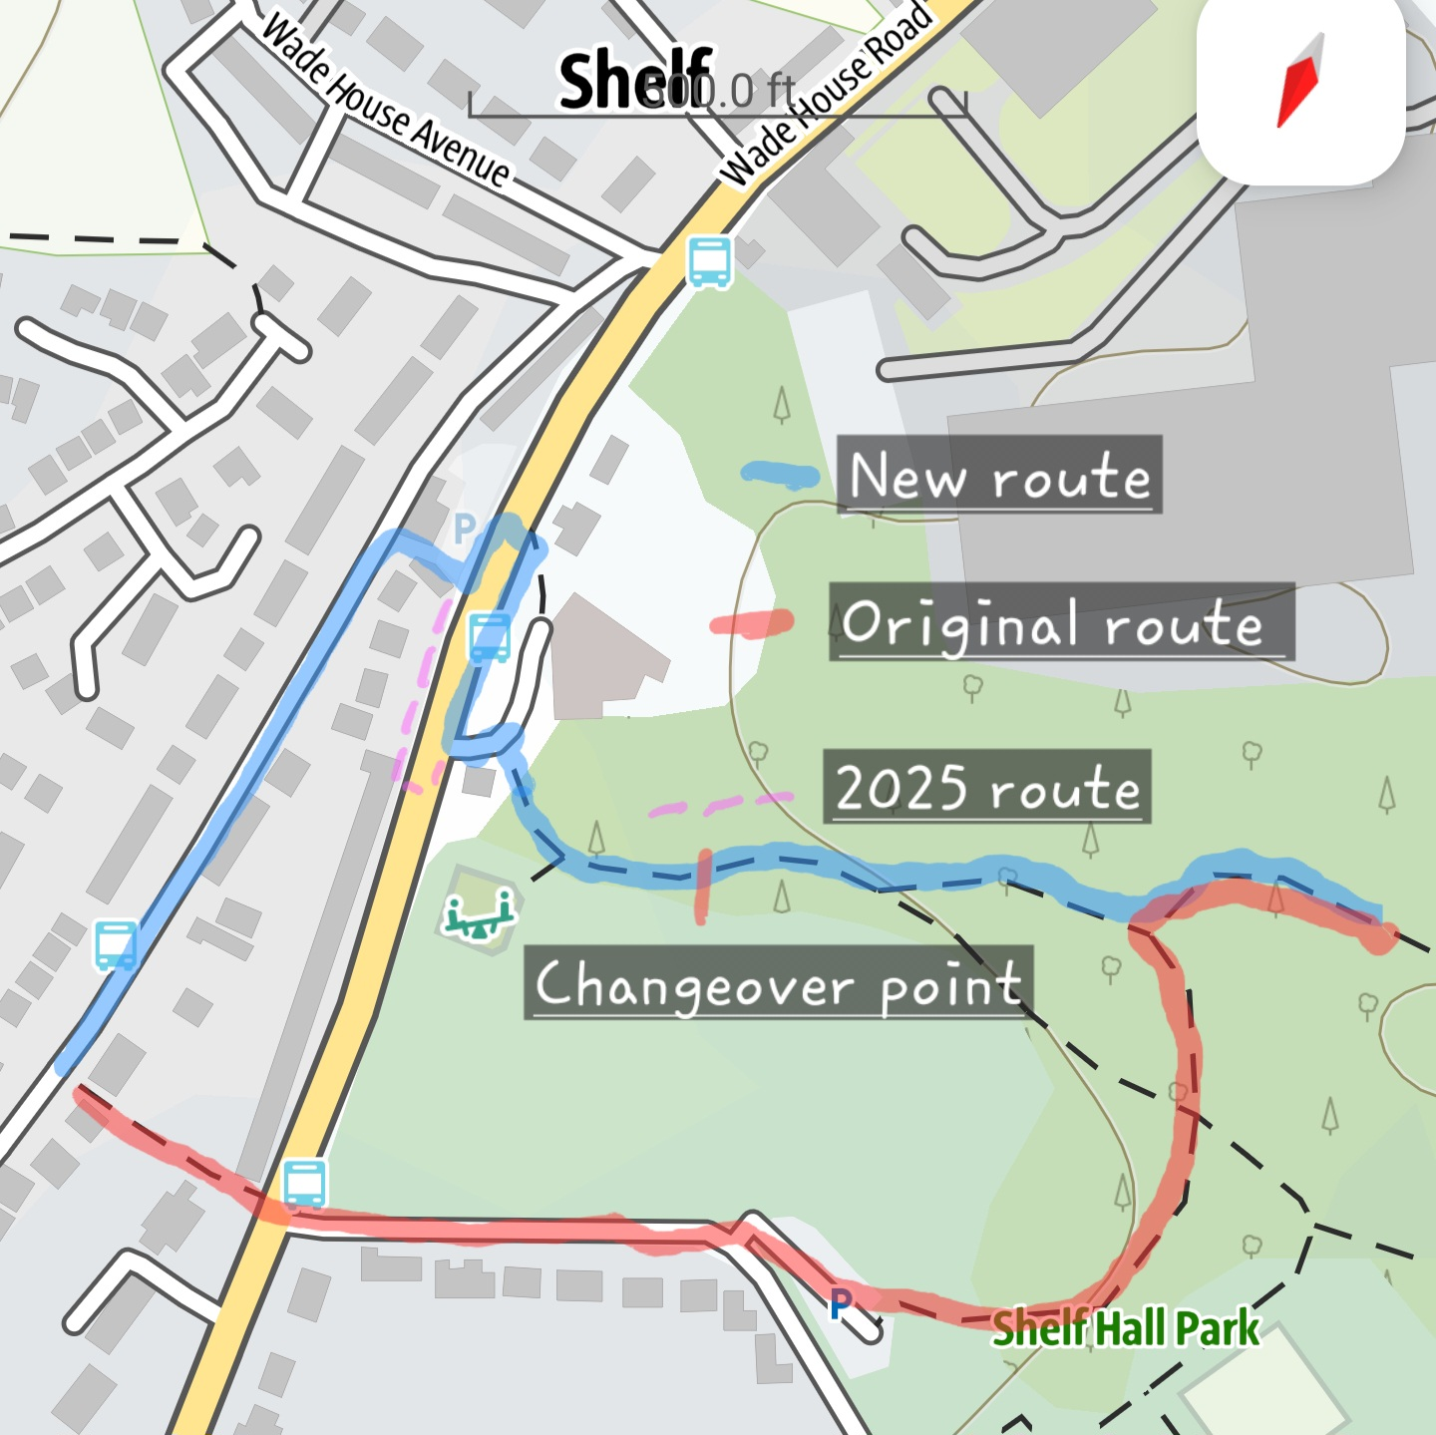
To ensure runners take the correct path in the Bradshaw to Holmfield section, behind Holdsworth House, please follow the directions below.
Coming through the fields from Bradshaw Church, turn right onto school lane then, immediately after the farmhouse, turn left. As you get to the end of the farm buildings (on your left) you come to a stile through the wall with a Calderdale MBC Footpath badge on it. Do not take this.
Instead, go left through the unmarked gateway. After about 40 metres go right on the wide path between two stone walls. Approximately 300 metres along that path you will come to a stile on your right. There is also a stile to your left at this point for reference. Take that right turn and follow the path to the industrial buildings in Holmfield.
Turn down West Street into Shelf Hall Lane and continue past the Junior School. REVISED ROUTE FROM 2025 ONWARDS: Ignore the official CW sign directing right and continue down to the Bottomley's Arm Public House. Turn right through the pub car park to Bradford Road (A6036) with the Fish & Chip Shop on your right as you pass through.

REVISED CROSSING FROM 2026 ONWARDS: On reaching Bradford Road, turn immediately left AND KEEP TO THE PAVEMENT. After approximately 50m, cross the road using the refuge crossing, then turn RIGHT. After about 30m turn LEFT into Shelf Village Hall car park. NOTE: ONLY THE CROSSING ABOVE MAY BE USED. CROSSING AT ANY OTHER POINT WILL RESULT IN DISQUALIFICATION.

Run through the car park towards the gated track, through the right of way to the side of the gate and down to the changeover.

At this changeover, there will now be a baton change.

LEG 6 – SHELF TO FINISH

NEW ROUTE FROM 2025 ONWARDS: From the changeover at Shelf Hall Park, continue down the path for approximately 100m, then turn left where a path leads from the main trail. Continue down this path for approximately 200m until it meets the steps. Turn left down the steps and over the beck.

Keep on path, left of the fencing for 200m, then through open fence. About 20m take path right, down and over wooden bridge follow path bearing left, up to top – metal gate on left. Go right – follow the way marker sign “Berry Bottoms” and keep on this path on top side of the woods all the way till you meet the “steps” half way up. You are back on the Calderdale Way. Up the steps and continue on the CW. This section will be marked out on the day.

Southowram go down West Lane and Change Lane as normal but DO NOT FOLLOW THE SIGNPOST CALDERDALE WAY half way down Change Lane (which goes left through the fields at EXLEY) but keep on the road all the way down past the school on your left to the junction. Turn left then 1st right down Exley Bank (steep cobbled road) to the main road. Keep right and take care when crossing the side road on your right (Jubilee Rd). Immediately after Jubilee Rd., go through a gap in the wall to your right and turn right, following the Hebble Trail towards Halifax (NOT UNDER THE SUBWAY AS BEFORE).

Finish
Follow the Hebble Trail until you arrive at Phoebe lane. Bear left there through the industrial units and across the bridge. Bear slightly left again up to Shaw Lane. You will see a steep cobbled climb opposite. Follow this up and over the railway bridge and onto Mansion Lane. Continue to the 2nd gap in the wall on the right where a flagged route will take you around the top of the football pitch to the finish by the Halifax Harriers club house.

Parking At The Finish
The grounds of Spring Hall only has parking available for officials. However, there is plenty of free parking at The Shay football stadium and on-street parking in the surrounding area. Note: Residential permit parking is mostly suspended at weekends BUT some will still operational so please read the signs carefully.
The area within the green lines in the diagram below shows where most of the free parking can be found. If you go towards the town centre, the red area, you will likely find paid parking meters.

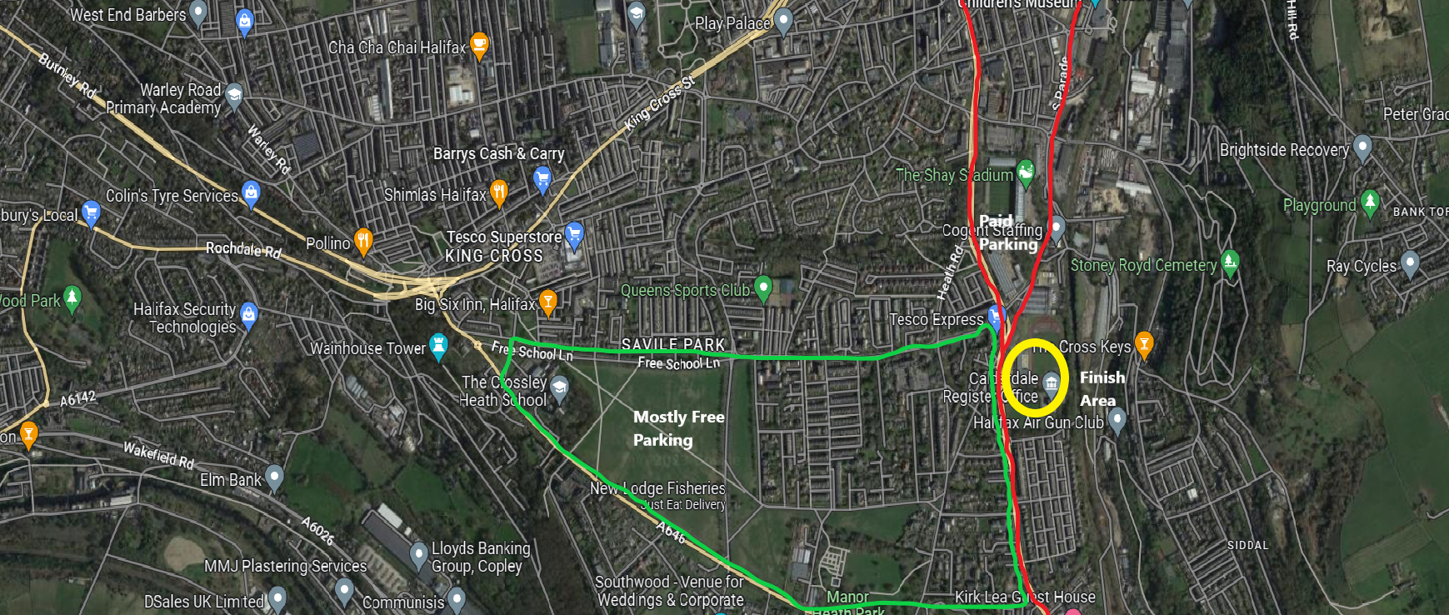

Photography & Filming
Please note that filming/photography is taking place at this event for promotional and archival purposes of Halifax Harriers. The photographs and recordings made are likely to appear on the associated website(s) and/or social media. If you would prefer not to be included please email entries.calderdalewayrelay@hotmail.co.uk

Halifax Harriers Wish You All The Very Best Of Luck For A Grand Day Out In Yorkshire!

See Medical Addendum Below

MEDICAL ADDENDUM

WHAT TO DO IN CASE OF INJURY OR MEDICAL EMERGENCY

This information is provided as guidance to getting the appropriate medical assistance depending on the nature of the injury and your location on the course.

REMEMBER, all pairs MUST run together to ensure the safety of each other.

It is highly recommended to carry a mobile phone in case of emergencies.

EMERGENCIES
If a competitor needs urgent medical attention the following protocol should be followed.

- If the competitor is close to a road and they can be safely transported to it, DIAL 999 and provide the emergency services with the information they ask for. Be sure of your position – use What3Words if you can.

- If the competitor is away from a road, dial the emergency number printed on your race number and race headquarters will coordinate with search & rescue to come to your assistance. Again, be sure of your position using What3Words if possible.

NOTE: If you do not have a mobile phone or there is no signal ask fellow competitors for assistance. Try using an alternative phone. Failing that, ask a fellow competitor to raise the emergency at the next available road crossing or changeover point using the above protocol.

In all cases, keep the casualty warm and comfortable

NON-EMERGENCIES
As per FRA guidance, it is recommended that each competitor carries a first aid kit.

If a competitor needs basic first aid equipment to deal with cuts etc. these will be available at each changeover point as self service items.

