Route at Shelf to Norwood Green
From the change-over point head down Bridle Stile towards the car park.
On reaching the car park veer left to take the path down the side of the car park. Follow the path for about 100m
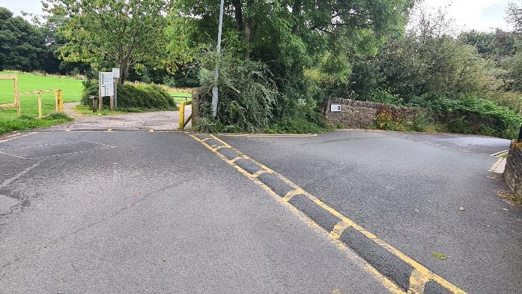

Take the small path on the left just after the sign post on the left.
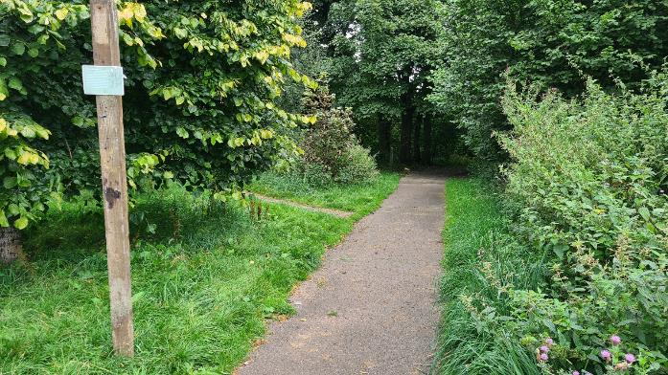

Follow the path for about 400 meters until reaching a tarmac road.
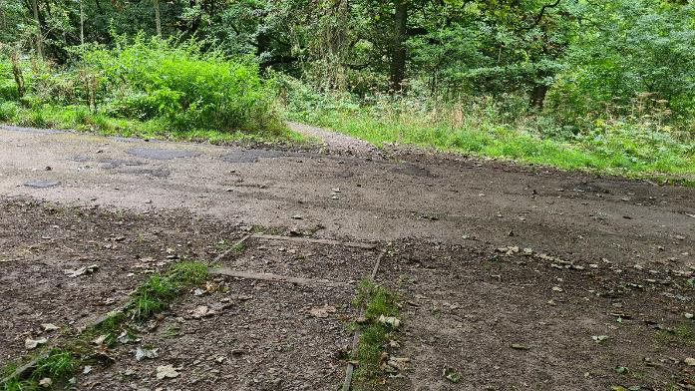

Cross the road and continue on the path for a short distance then take path on right where the way marker sign with a yellow top is and down the steps.
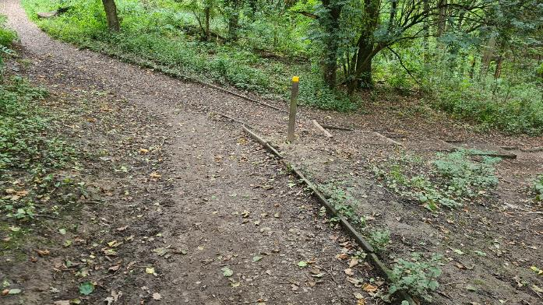

Follow steps down and over the beck, turning right after crossing.
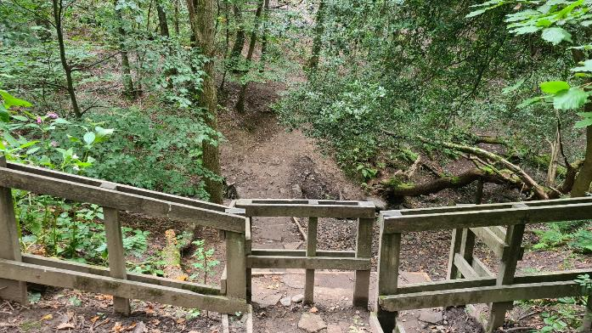
Keep on the path for about 200 meters until reaching a fence.
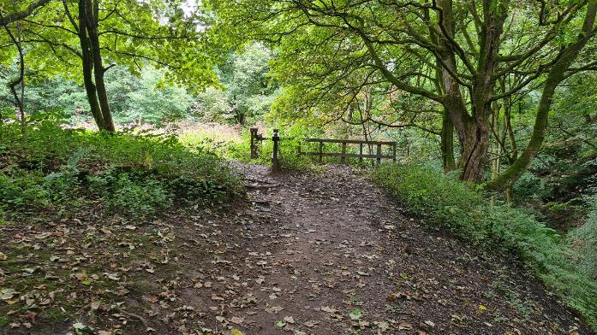

Follow the path round to the left and up the hill.
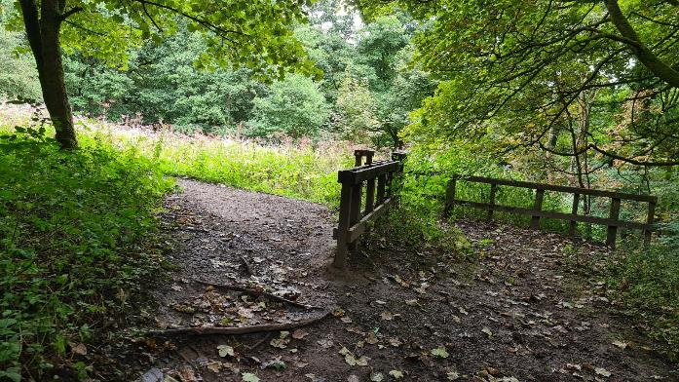

After about 200 meters pass through the open fence and look out for the right turn about 50 meters ahead.
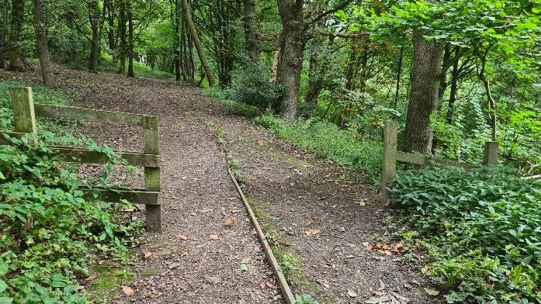

Take the right path, down
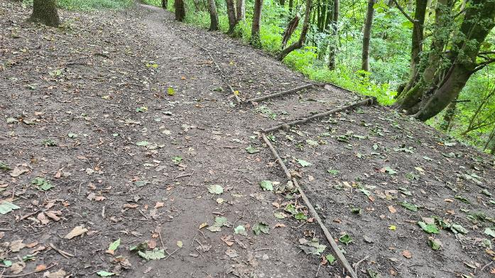

On reaching the wooden bridge, cross it and follow the path bearing left, up to the top.
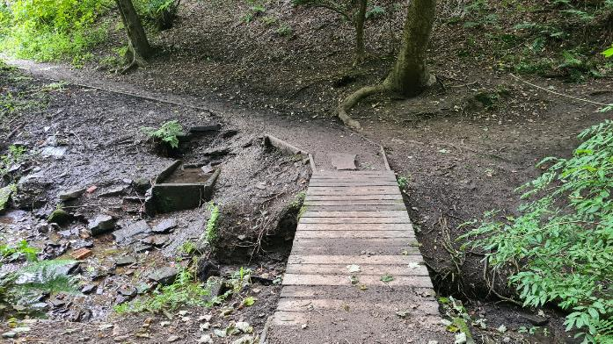

At the top of the hill there will be a metal gate on your left. Turn right here.
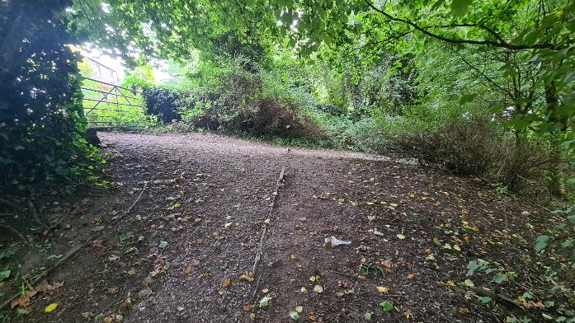

Keep on this path on the top side of the woods. Always take the upper path where there are options to go down.
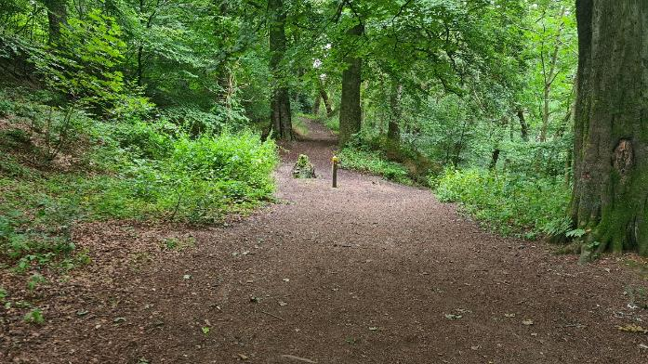

Continue all the way until you meet the steps half way up.
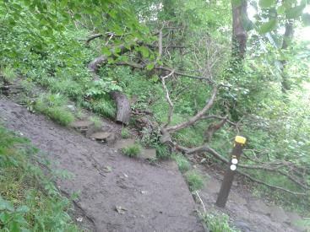
You are back on the Calderdale Way.

From Shelf, on reaching this point turn left from the path and climb the steps to the stile
At the top of the steps, go through the stile and turn right down a concreted farm track 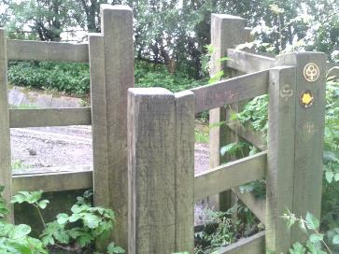
Keep to the left of the road and through the gate to pass the buildings on the right. Ahead is the stile in the photo below. Cross the stile and stay on the right hand path, this is strewn with building rubble and drops down to the right. DO NOT TAKE THE UPPER PATH TO THE LEFT AS THIS IS NOT A PERMISSIVE PATH
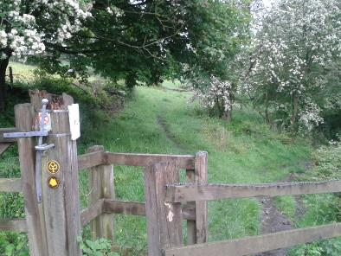
After about half a mile you exit the trees
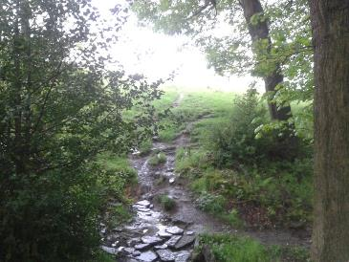
Follow this path and head diagonally towards the pylon to the stile
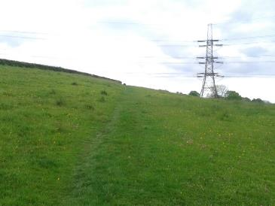
Go through the stile and keep the wall on your right, follow this path across two fields till you reach the farm. and road
